26.16: a) 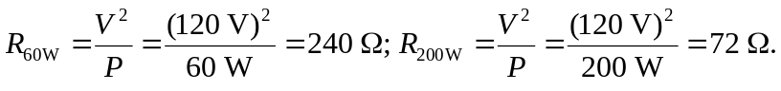
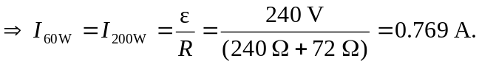
b)
c) The 60 W bulb burns out quickly because the power it delivers (142 W) is 2.4 times its rated value.

